**LOAN DATA ANALYSIS**

**SUMMARY** – MAKE DATA-DRIVEN DECISIONS, TRACK LOAN PORTFOLIO’S HEALTH, IDENTIFY TRENDS TO INFORM LENDING STRATEGIES

KPI’s:

1. Total loan applications





1. Month to date application

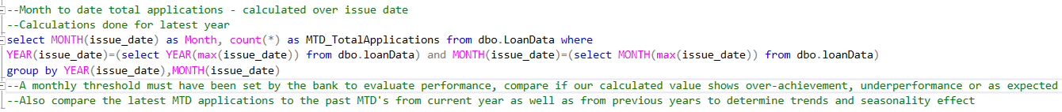



1. Month over month growth

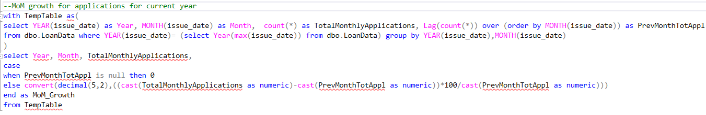

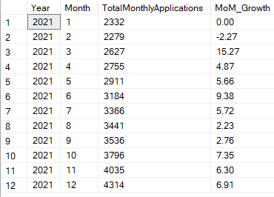

1. Total disbursement amount





1. Month to date disbursed amount





1. Month over month change

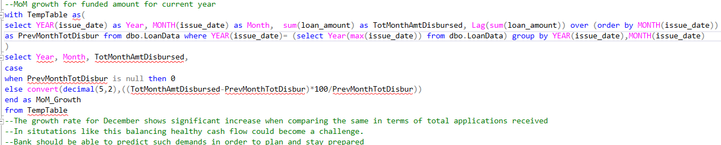

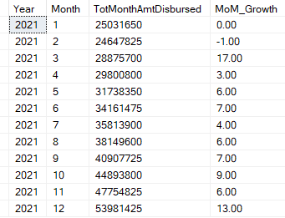

1. Total repayment amount received – essential for assessing the bank’s cash flow





1. Month to date repayment amount received





1. Month over month change

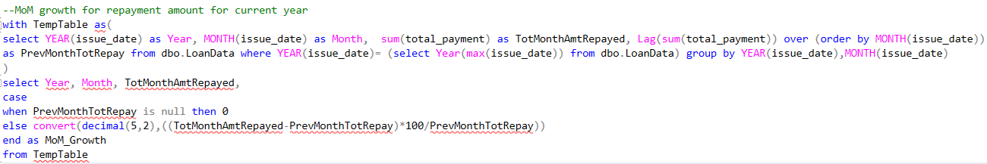

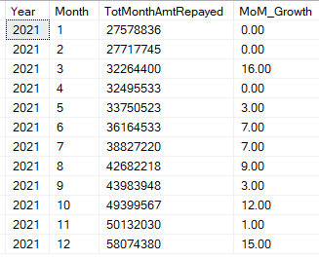

1. Average interest rate across all loan categories





1. MTD average interest rate





Validating this by looking at the number of loan application in each category in December



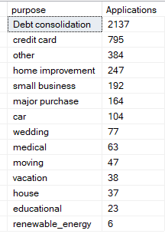

1. MoM variation in Interest rates – insights into lending portfolio’s overall cost

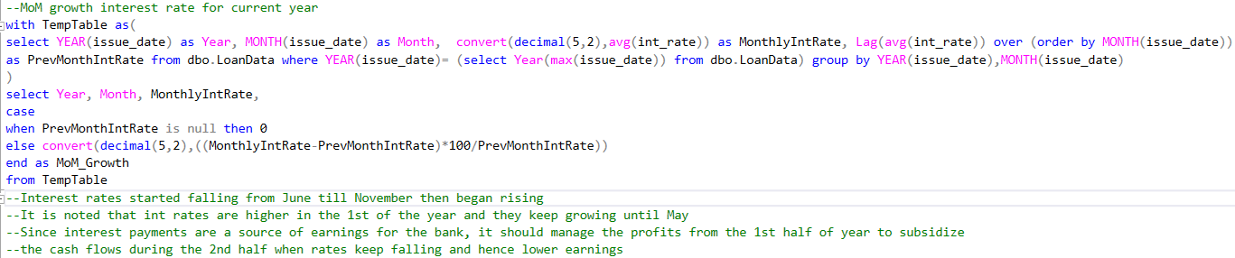

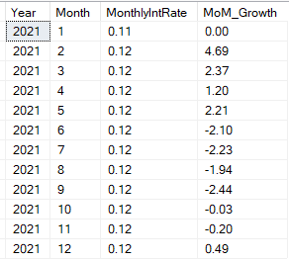

1. Average borrower DTI ratio for all loan categories – helps gauge borrower’s financial health











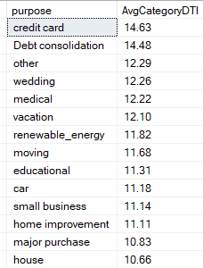

1. MTD average DTI ratio





1. MoM average DTI fluctuation

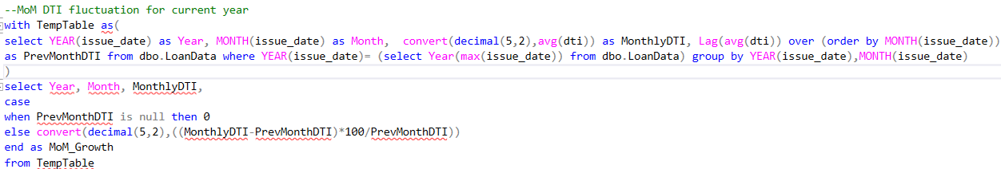

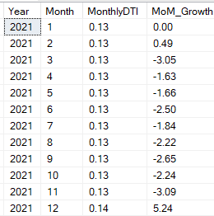

1. Good loans vs Bad loans – Good loans are where the customer has paid off the total amount or is regularly paying instalments for a current loan account. Bad loans are where customers are defaulting



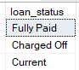

* Total good loans/bad loans (absolute nos.) among total loan applications (%)

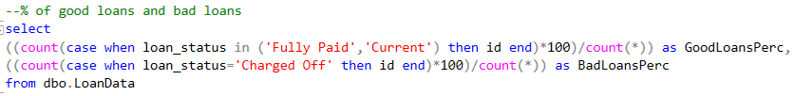



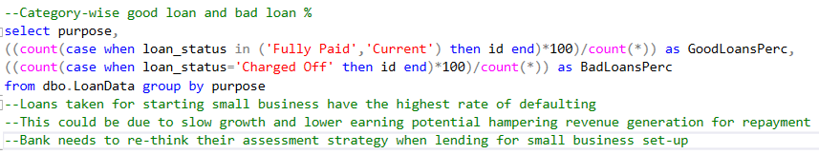

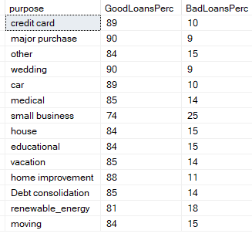

* Total good loan/bad loan disbursed amount

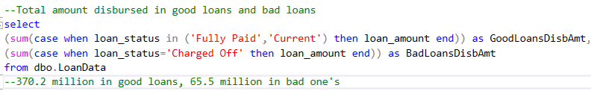



* Total good loan/bad loan repayment amount

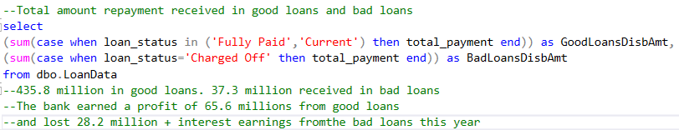



1. Performance of loans & lending operations – An overview of all the above categorized by Loan status



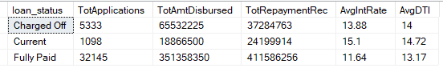

Month to date summary

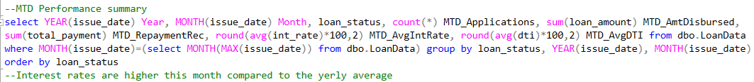

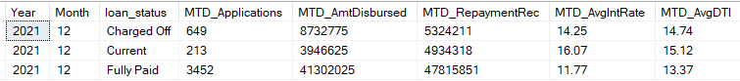

**OVERVIEW**

1. Issue Date (Monthly pattern) – identify seasonality & long-term trends



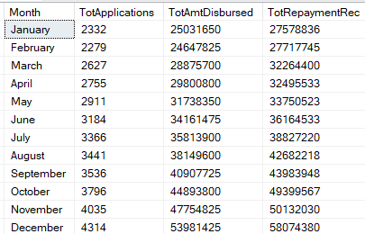

1. Address state (Regional analysis) – identify states with significant lending activity and assess regional disparities



--States with significant lending activities. Additions to lending portfolio can be done based on needs analysis to further increase lending in these active regions.

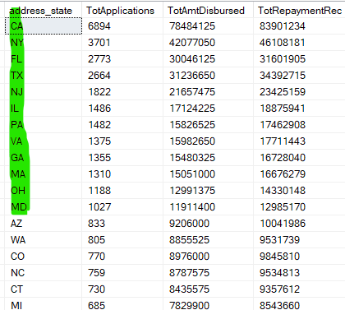

--States with significantly low lending activities. This could be due to low economic status and lack of literacy in the region (probably rural). New schemes can be launched as special regional offerings by revamping the bank’s portfolio to meet the demand specific to these regions. Additionally, the bank can run educational campaigns to inculcate lending behaviour/practices into the residents who may be technology skepticals.

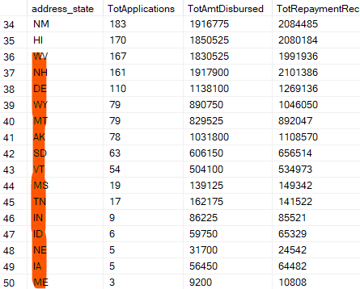

1. Term analysis – identify loan disbursements across various term lengths





1. Employee length analysis – asses impact of employment history on loan application



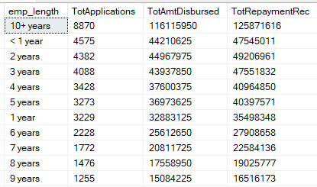

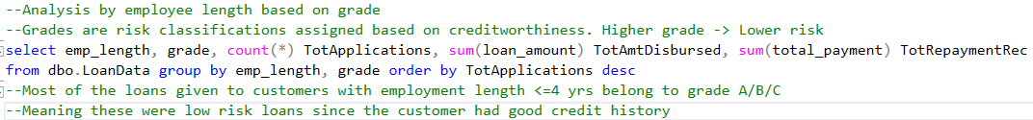

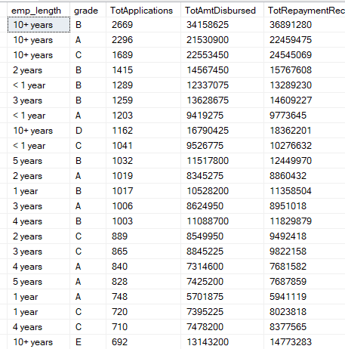

1. Loan purpose analysis – understand the primary reason for borrowers to seek financing

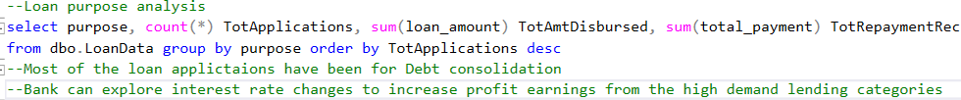

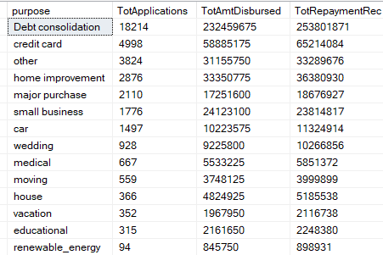

1. Home ownership analysis – how home ownership impacts loan applications and disbursements

